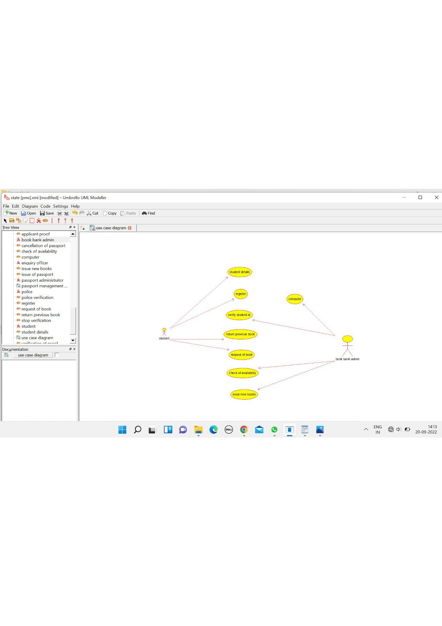

computer

/**

* Class COMPUTER

*/

public class COMPUTER {

//

// Fields

//

private void student_record;

private void booklist;

//

// Constructors

//

public COMPUTER () { };

//

// Methods

//

//

// Accessor methods

//

/**

* Set the value of student_record

* @param newVar the new value of student_record

*/

private void setStudent_record (void newVar) {

student_record = newVar;

}

/**

* Get the value of student_record

* @return the value of student_record

*/

private void getStudent_record () {

return student_record;

}

/**

* Set the value of booklist

* @param newVar the new value of booklist

*/

private void setBooklist (void newVar) {

booklist = newVar;

}

/**

* Get the value of booklist

* @return the value of booklist

*/

private void getBooklist () {

return booklist;

}

//

// Other methods

//

/**

*/

public void maintain_student_record()

{

}

/**

*/

public void enter_issue()

{

}

/**

*/

public void order_new_author()

{

}

/**

*/

public void check_availability()

{

}

}

STUDENT

/**

* Class STUDENT

*/

public class STUDENT {

//

// Fields

//

private void student_details;

//

// Constructors

//

public STUDENT () { };

//

// Methods

//

//

// Accessor methods

//

/**

* Set the value of student_details

* @param newVar the new value of student_details

*/

private void setStudent_details (void newVar) {

student_details = newVar;

}

/**

* Get the value of student_details

* @return the value of student_details

*/

private void getStudent_details () {

return student_details;

}

//

// Other methods

//

/**

*/

public void request_for_books()

{

}

/**

*/

public void return_previous_books()

{

}

/**

*/

public void register()

{

}

}

ADMIN

/**

* Class ADMIN

*/

public class ADMIN {

//

// Fields

//

private void student_details;

private void booklist;

//

// Constructors

//

public ADMIN () { };

//

// Methods

//

//

// Accessor methods

//

/**

* Set the value of student_details

* @param newVar the new value of student_details

*/

private void setStudent_details (void newVar) {

student_details = newVar;

}

/**

* Get the value of student_details

* @return the value of student_details

*/

private void getStudent_details () {

return student_details;

}

/**

* Set the value of booklist

* @param newVar the new value of booklist

*/

private void setBooklist (void newVar) {

booklist = newVar;

}

/**

* Get the value of booklist

* @return the value of booklist

*/

private void getBooklist () {

return booklist;

}

//

// Other methods

//

/**

*/

public void verify_student_id()

{

}

/**

*/

public void check_for_book_availability()

{

}

/**

*/

public void issue_books()

{

}

/**

*/

public void order_for_new_author()

{

}

/**

*/

public void maintain_student_detail()

{

}

}

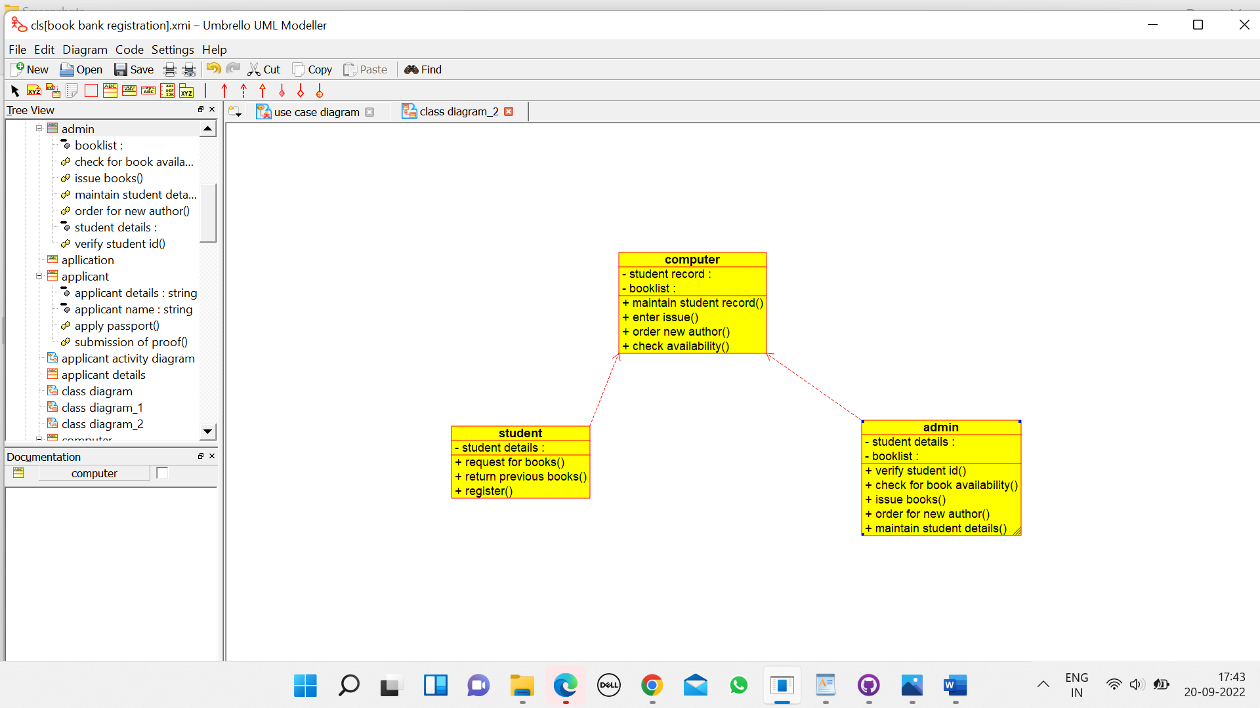

|  |
| --- |
| "cut |